### 4.3.2 SUBSYSTEM DECOMPOSTION

To reduce the complexity of the solution domain, we decompose a system into simpler parts,  
called subsystems. The main need of this portion is to design the external part of the system. In  
this project, there are four subsystem decompositions.

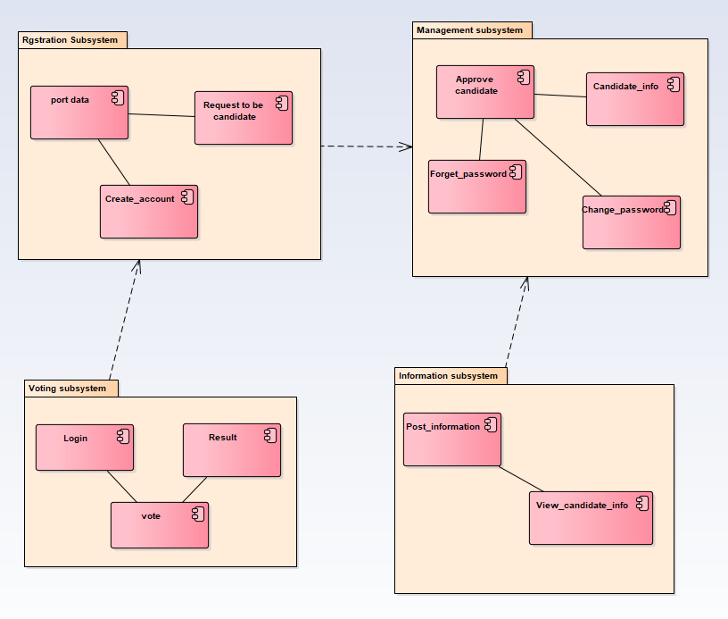

**Figure 29 Subsystem decomposition**